0. Get LAMMPS and SAMSON Connect
1. https://docs.lammps.org/Install.html
2. https://www.samson-connect.net/pricing
Everything should work with the Free version of SAMSON Connect

1. Get structure files
Get them here:

2. Load the .PDB

3. Select Anchors
Shift to add to the selection
g is the group short cut or go to Edit > Group
name the group “anchor”
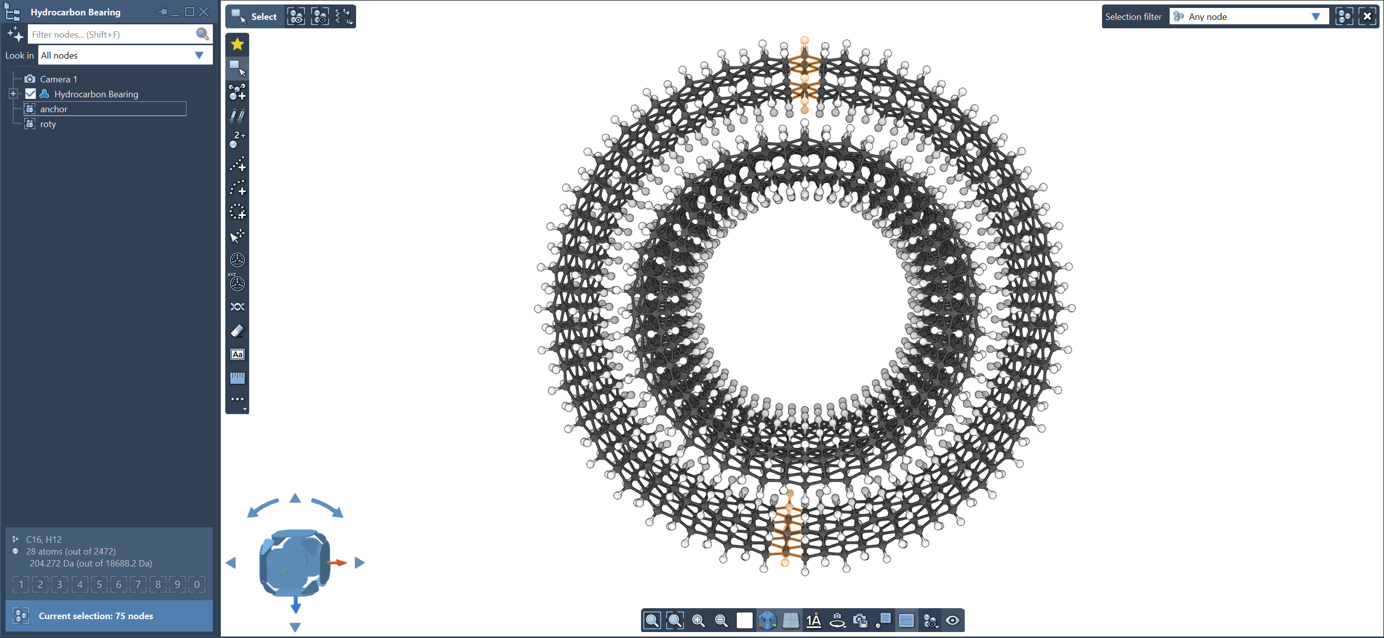

4. Select the Rotational Group
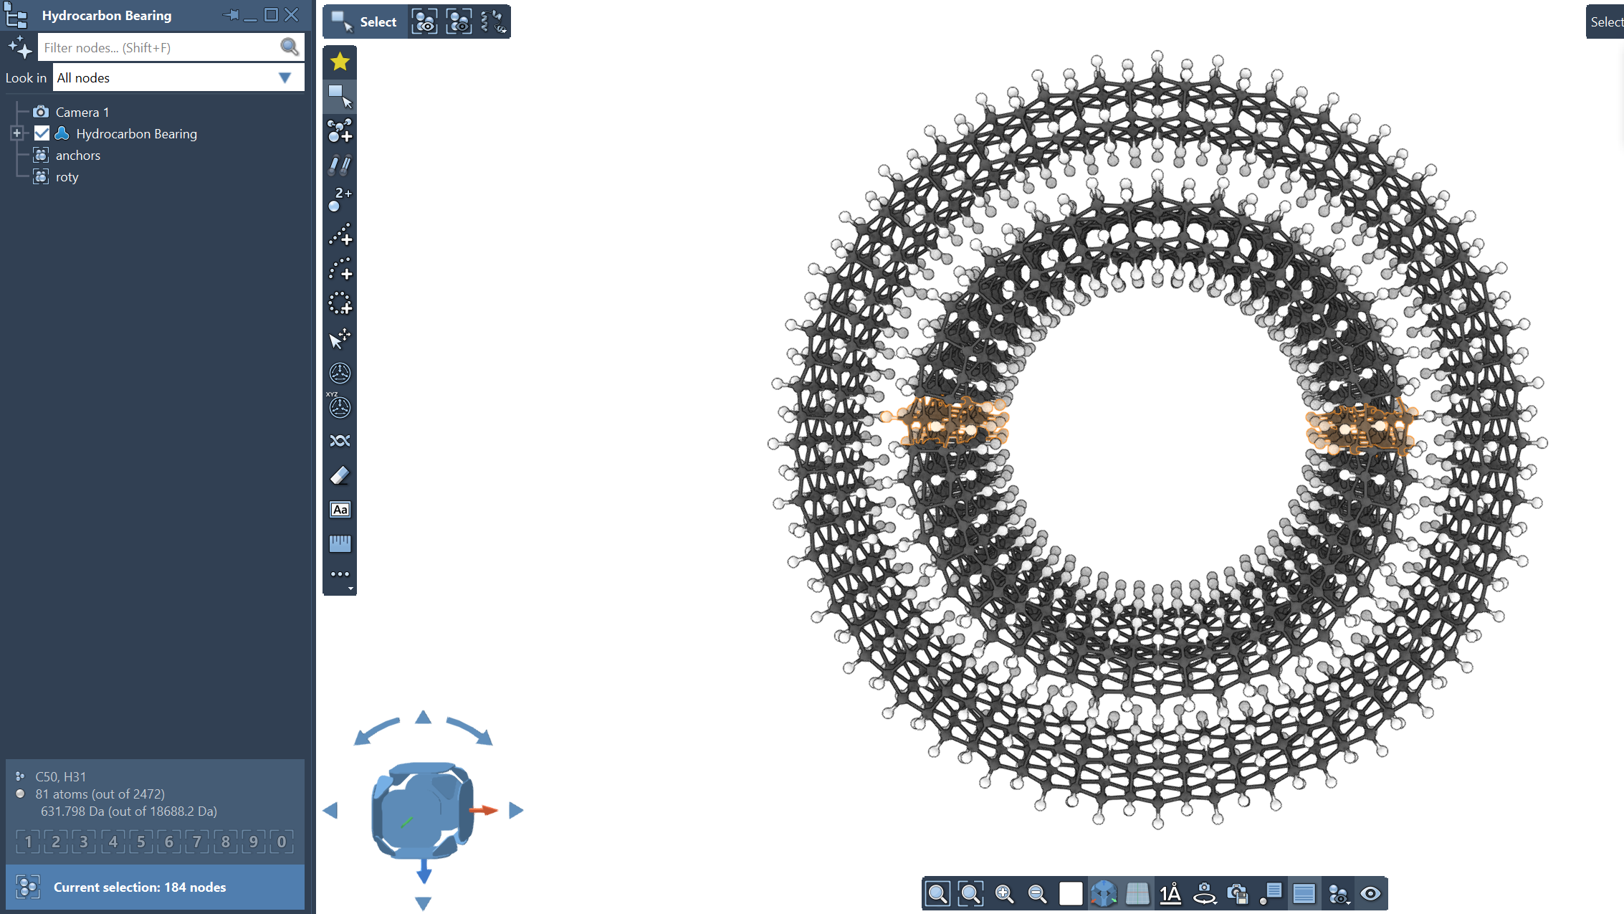
Name the group “roty”

5.Get the SAMSON2LAMMPs Script
Get it here: https://github.com/mooreth/misc/blob/main/SAMSON2LAMMPS_atomtypes.py

6. Initialize the Python Console in SAMSON Connect
Interface > Python Console. This add the new tab to the Inspector Window
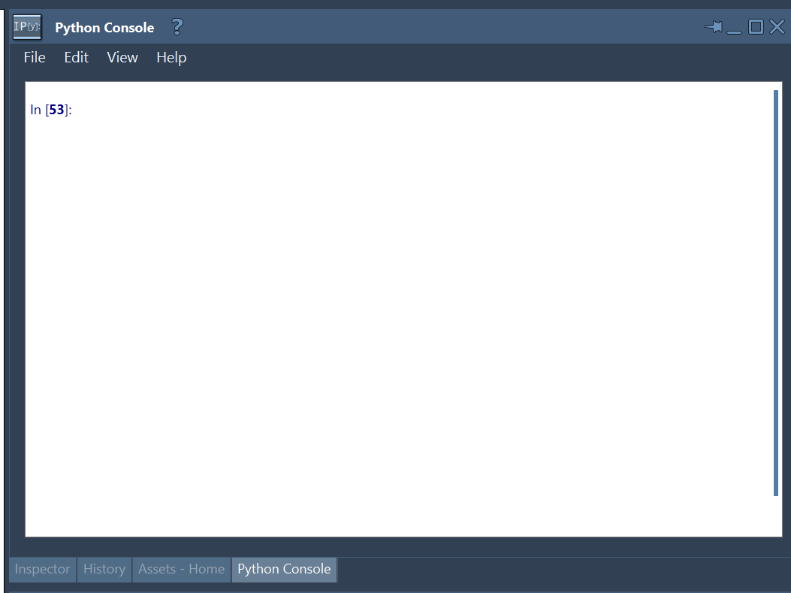

7. Edit Script
1. Change line 4 to the working directory
2. Change line 75 and 79, 122, and 123 to roty, this is just the name of the group
You could also do a search and replace roty for rotz
3. Change line 178 (optional)
4. Change line 187 to the .data output file directory and name

8. Run the Script
In the Python Console, File > Run Python Script File

9. Get Centroid
Copy the centroid from the Python Console tot he roty fix in the input file
fix rotatebearing_fix roty move rotate -3.037 1.177 -0.749 0.0 0.0 1.0 125

10. Run Energy Minimization
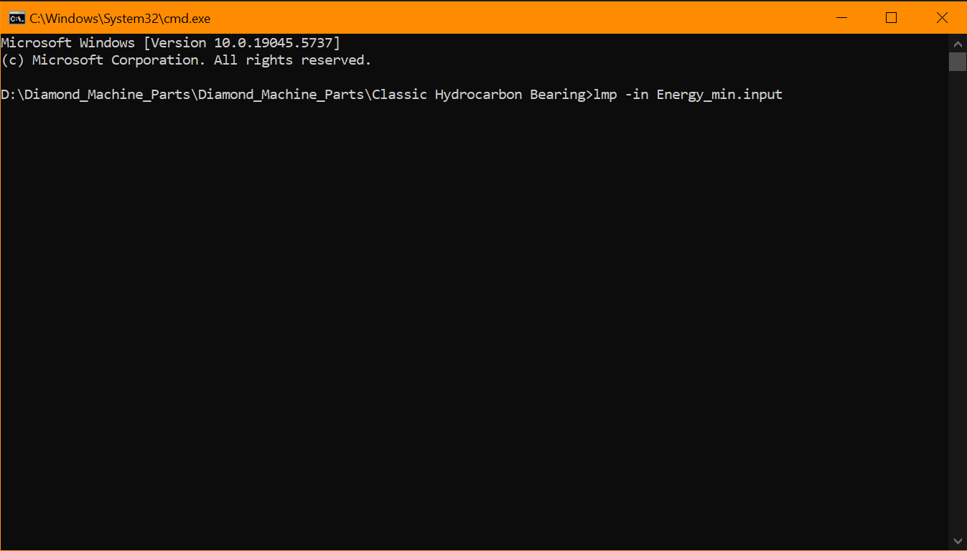

11. Run Bring_to_TEMP
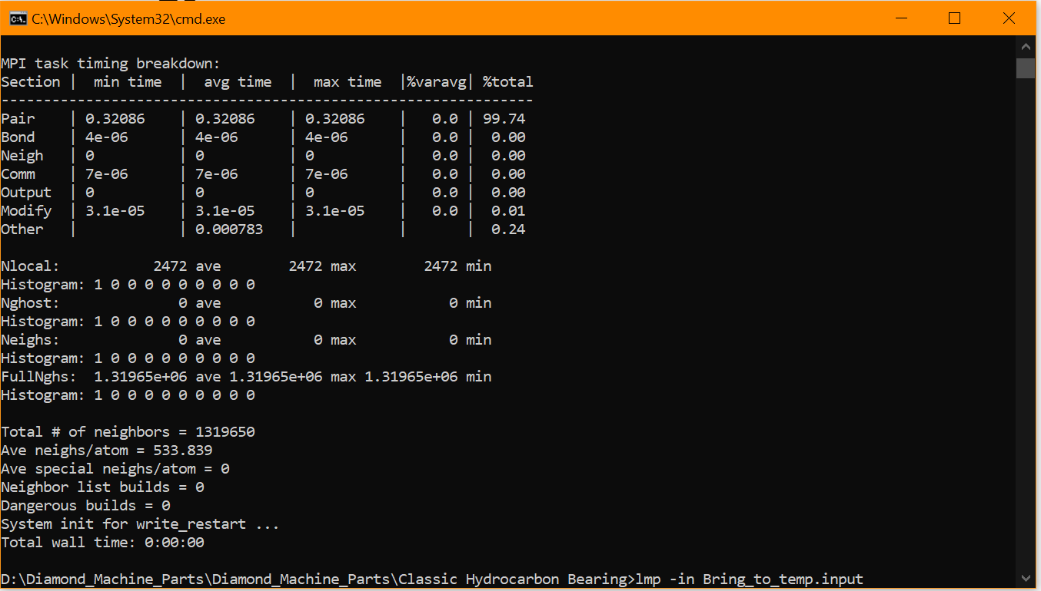

12. Run Hydrocarbon_Bearing.input

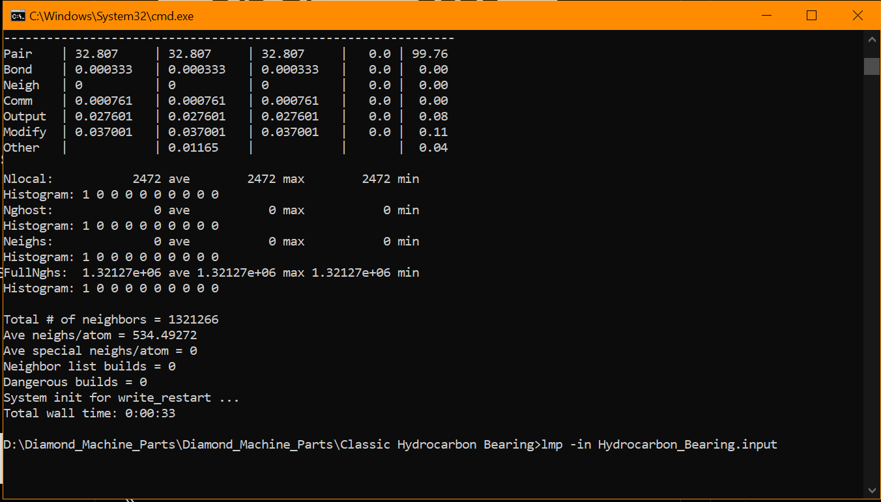

13. Load the trajectory

File > Open. ….

